Final Document

1. Abstract
As technology becomes deeply intertwined with modern society, the ability of automated systems to distinguish human faces from everyday objects has emerged as a fundamental necessity in computer vision. Demystifying these systems reveals that they are processes grounded in rigorous mathematical foundations. The objective of this study is to clarify the mathematical framework behind facial detection and to implement a functional classification model in Python. Using Singular Value Decomposition (SVD), this project processes a dataset of 5000 facial images to construct a low-dimensional principal subspace. By calculating the reconstruction error using the Euclidean norm, the model establishes a mathematical metric to effectively differentiate human faces from non-facial items. Ultimately, this approach demonstrates how multivariable optimization and linear algebra can efficiently solve high-dimensional data classification challenges, bridging the gap between theoretical mathematics and practical computational applications.

2. Introduction
How do you unlock your smartphone every morning? How do security cameras in a smart circuit distinguish a human being from a moving shadow or an object? How do social media filters overlay graphics onto your face? The answer to all these questions lies in the field of computer vision, specifically within facial detection and recognition systems. As you may have realized, facial recognition is a tool that is everywhere.
To truly comprehend the engineering behind these systems, it is necessary to first acknowledge the massive computational challenges they face. The main challenge lies in the data overload. A low-quality image of just 100 × 100 pixels has 10,000 dimensions. To put this into perspective, a standard High Definition (HD) image consists of 1920 × 1080 pixels, which translates to over two million variables. Processing, storing, and comparing every new frame or object against a vast library of raw pixels in real-time is computationally expensive and highly inefficient.
To overcome this geometric bottleneck, mathematical frameworks must find a way to simplify this massive amount of data without losing the crucial information that defines a human face. This is where Singular Value Decomposition (SVD) becomes an indispensable tool. SVD allows us to break down high-dimensional image matrices into their most fundamental geometric components. By focusing on these core structures, we can reduce the dimensionality of the problem, filtering out noise and redundancy.

3. Literature Review
The mathematical foundations of facial recognition through SVD are grounded in decades of research spanning linear algebra, numerical analysis, and computer vision. The work of Turk and Pentland (1991) introduced the concept of eigenfaces as a practical approach to facial recognition, demonstrating that human faces could be effectively represented as linear combinations of orthonormal basis vectors derived from SVD. This pioneering work established the theoretical framework that underpins modern facial recognition systems.
Subsequent research by Belhumeur, Hespanha, and Kriegman (1997) expanded upon the eigenfaces methodology, introducing Fisher faces and demonstrating the superiority of discriminant analysis over principal component analysis for facial recognition tasks. Their work highlighted the importance of selecting optimal basis vectors that maximize the separation between different facial classes while minimizing within-class variance. This research emphasized that the quality of facial recognition depends not merely on dimensionality reduction, but on the strategic selection of features that best distinguish between different individuals.
More recent contributions by Falini (2022) have addressed the challenge of truncation criteria in SVD applications. In her comprehensive review of truncated SVD selection methods in data science, Falini examines various statistical approaches for determining the optimal number of singular values to retain. Her work is particularly relevant to facial recognition, as the choice of truncation point k directly impacts both computational efficiency and classification accuracy. Falini's research demonstrates that objective, data-driven criteria for truncation selection significantly outperform heuristic approaches.
The integration of SVD with machine learning frameworks has been further explored by Stoll (2020), who provides a comprehensive survey of matrix methods in data science. Stoll's analysis situates SVD within the broader landscape of dimensionality reduction techniques, comparing its performance with alternatives such as Nonnegative Matrix Factorization (NMF) and CUR decomposition. While acknowledging the mathematical optimality of SVD for low-rank approximation in the Frobenius norm sense, Stoll notes that the orthogonality constraints of SVD may limit interpretability in certain applications. Nevertheless, for facial recognition, where the orthogonal basis vectors directly correspond to eigenfaces, SVD remains the most theoretically justified and practically effective approach.
Contemporary implementations of SVD-based facial recognition have benefited from advances in numerical algorithms. The work of Muller, Magaia, and Herbst (2004) provides detailed analysis of how SVD can be efficiently implemented for facial recognition tasks, including practical considerations for image preprocessing, matrix construction, and classification thresholds. Their comprehensive treatment of eigenfaces and 3D reconstructions demonstrates the versatility of SVD beyond simple binary classification, extending to more complex facial analysis tasks.

4. Methodology
Unlike humans, computers do not perceive images visually. Instead, a digital image is mathematically represented as a matrix of numerical values. In color images, each pixel is described using the RGB (Red, Green, and Blue) model, meaning that the image is composed of three separate matrices, one for each color in the scale. Although this representation preserves detailed color information, it also significantly increases the dimensionality of the data. To simplify the computational process, the images used in this project are converted to grayscale, reducing the three-channel representation into a single matrix while still preserving the essential structural features of the face. In grayscale images, each pixel corresponds to an intensity value ranging from 0 to 255, where 0 represents black and 255 represents white.

Even after converting the dataset to grayscale, the computational complexity remains significantly elevated if the images retain their original dimensions. To mitigate this, the spatial resolution of each image is standardized to 100 x100 pixels. This reduction is achieved by resampling the original pixel density over a smaller grid while preserving the overall geometric structure and essential facial features; this means that neighboring pixels are effectively merged or averaged during this process, allowing the image to preserve its overall facial geometry while reducing the total amount of stored information. Throughout this resizing process, the aspect ratio is strictly maintained to prevent artificial distortions in facial proportions. As a result, each processed image retains its critical visual information while yielding a highly efficient matrix representation.

With the uniform dimensions established, the construction of the training data matrix $A$ begins through a process known as vectorization. This technique consists of taking all the columns of the image matrix and stacking them on top of each other to transform the two-dimensional image into a single, long column vector. This mathematical transformation maps the image from a matrix space of $R^{100x100}$ into $R^{10,000}$. In result, each column of A represents a single flattened face.

Once matrix A is constructed, we continue with the SVD process. SVD states that any real matrix A can be factorized into the product of three distinct constituent matrices:

$$A=U\sum{}V^{T}$$
Although the Python code does this automatically by the usage of libraries (we don’t have to write all the mathematical formulas into code), it is essential to clarify the geometric and algebraic role of each matrix involved.

The first component, U, is an orthogonal matrix (its vectors are orthogonal and normalized) composed of left singular vectors. In the context of our face detection project, each column of U retains the same spatial dimension (10,000 elements) as our flattened input images. When these columns are reshaped back into a 100 x 100 grid, they reveal abstract base components known as Eigenfaces. These orthonormal columns serve as the fundamental coordinate system or base axes for our face detection framework. The earliest columns capture the most prominent geometric variations across the training set (such as overall face shape or dominant lighting gradients), providing the mathematical foundation needed to construct our lower-dimensional classification subspace.

The second component of the factorization is , which is a rectangular pseudo-diagonal matrix. The diagonal entries of this matrix contain the singular values of A, arranged in descending order. In our model, these singular values represent the weight or relative importance of each corresponding geometric feature in U. The larger the singular value, the more statistical variance and critical facial information that specific Eigenface captures. By analyzing the decay of these values, we can determine the optimal truncation point k, allowing the Python code to discard columns associated with lower singular values, which represent computational noise or irrelevant background details.

Finally, the matrix $V^{T}$represents the transpose of the right singular vectors. This is an orthogonal matrix whose rows provide the specific coefficients or coordinates required to reconstruct each original training image as a linear combination of the orthonormal columns in U. While $V^{T}$ is essential for the internal mathematical consistency of the SVD and the initial training phase, our detection system will primarily rely on the truncated basis of U to analyze and classify completely new, unseen objects.
After the complete Singular Value Decomposition is computed, a dimensionality reduction process known as truncation is performed. The singular values contained in Σ are arranged in descending order according to their contribution to the overall variance of the dataset. Since the first singular components capture the most significant geometric structures shared among facial images, only the first k dominant columns of U are retained, where k≪10,000. The remaining columns, associated with smaller singular values, primarily represent minor variations, or computational noise, and are therefore discarded. As a result, the original high-dimensional basis is transformed into a reduced orthonormal framework known as the truncated matrix $U_{k}$​, which defines the principal facial subspace used for classification.
With the truncated facial subspace $U_{k}$ fully isolated in the system's memory, the model is now prepared to evaluate any completely new image vector. Before projecting a new image into the facial subspace, the input vector $x_{new}$ is centered by subtracting the average face vector, $μ$, from it. This normalization step removes the common baseline facial structure shared across the dataset, allowing the model to focus exclusively on the most significant geometric variations. Once centered, the new vector is orthogonally projected onto the reduced facial subspace. Mathematically, the resulting projected vector represents the optimal approximation, or “reconstruction,” of the input image using exclusively the dominant facial features. It is calculated as follows:
$$y = U_{k}U^{T}(x_{new}-μ)+μ$$
Where $μ$ is the average face vector of our training database, which serves as the geometric baseline and is calculated as follows:
$$μ=\frac{1}{N}\sum_{i=1}^{N}{}x_{i}$$
Here, N represents the total number of facial images in the dataset, and $x_{i }$represents each vectorized face.
To evaluate the quality of this reconstruction, we define a multivariate error function based on the Euclidean Norm. This error represents the distance between the original input vector and its approximation.

5. Implementation, Results and Limitations

5.1 Per-Image Normalization
Prior to constructing the training matrix A, an additional preprocessing step is applied to each vectorized image: per-image normalization. Each image vector x is standardized by subtracting its own pixel mean and dividing by its own standard deviation, yielding a zero-mean, unit-variance representation. This operation ensures that the face subspace captures structural and geometric patterns—such as the relative positioning of facial features and bilateral symmetry—rather than global illumination levels. Without this step, the dominant singular vectors would encode brightness gradients common to any image, causing the model to misclassify low-complexity, uniformly lit objects as human faces. Images whose standard deviation is negligible (uniform images) are identified immediately as non-faces, since they contain no structural information whatsoever.

5.2 Python Implementation
The mathematical pipeline described in this document was implemented in Python across three specialized modules. The preprocessing module (utils.py) handles image loading, grayscale conversion, resizing to 100×100 pixels, and per-image normalization. The training module (train.py) constructs the data matrix A, computes the full thin SVD via numpy.linalg.svd, applies the automatic truncation criterion, calibrates the decision threshold, and serializes the resulting model to a compressed binary file (face_model.npz) containing the truncated matrix U_k, the mean face vector, the threshold θ, and the full singular value spectrum. The classification module (detector.py) loads this serialized model and applies the projection-reconstruction pipeline to new input images in real time, supporting both single-image file classification and live webcam-based detection via an OpenCV video loop. All interaction is handled through a unified command-line interface in main.py.

5.3 Experimental Results
Figure 1 presents the singular value spectrum of the training matrix, plotting the 200 largest singular values in descending order. The steep initial decay—with σ₁ = 3065.7 dropping sharply over the first 25 components before gradually flattening—confirms that facial information is highly concentrated in the leading singular vectors. The long, flat tail beyond component 50 corresponds to minor variations and noise. This spectral decay is the empirical foundation for truncation: retaining only those components associated with large singular values captures the essential structure of the training data.
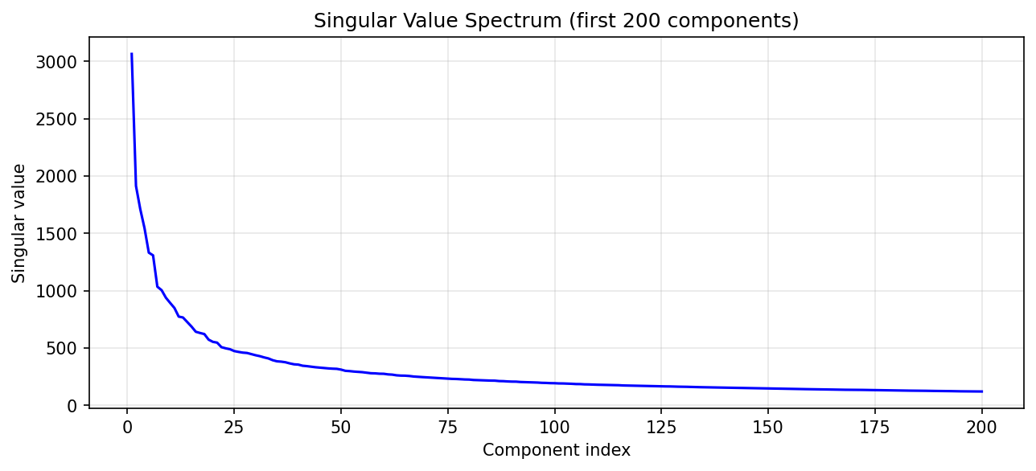Figure 2 shows the cumulative explained variance as a function of the number of retained components k. The curve rises steeply at first and then plateaus, crossing the 95% threshold at k = 512. This means that 512 eigenfaces—out of a theoretical maximum of 5,000—account for 95% of the total statistical variance in the dataset. The remaining 4,488 components are discarded, reducing the dimensionality of the problem by 89.8% while preserving nearly all discriminative facial information. The value k = 512 was selected automatically by the training algorithm and defines the size of the principal facial subspace used for all subsequent classifications.
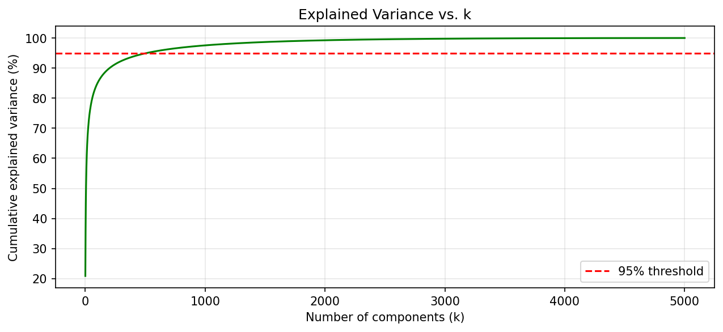Figure 3 presents the distribution of reconstruction errors across all 5,000 training face images, with the calibrated decision threshold θ = 27.79 indicated by the vertical red line. The distribution approximates a bell curve centered at μ = 20.82 with a standard deviation of σ_err = 3.96, reflecting the consistency of the facial subspace in reconstructing genuine human faces. The threshold, set at the 95th percentile of this distribution, guarantees that 95% of training faces are correctly accepted while establishing a statistically principled upper bound for admitting new images as faces. Validation on a held-out set of 100 face images yielded a correct classification rate of 95%, consistent with the design criterion.
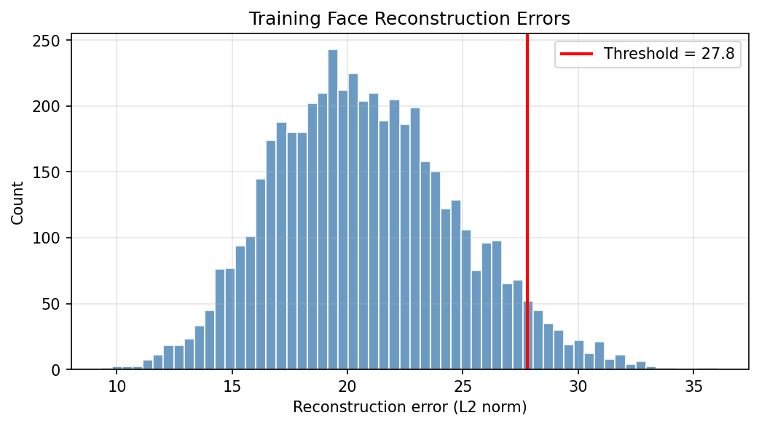

5.4 Limitations of the SVD-Based Approach
The SVD classifier operates on a global 100×100 representation and makes no use of local spatial features. This introduces a fundamental limitation: any image whose normalized pixel distribution is statistically consistent with the learned eigenface subspace will produce a low reconstruction error, regardless of its semantic content. A concrete example is a high-resolution photograph of a metallic cube. When downsampled to 100×100 pixels, the image reduces to a smooth, nearly symmetric pattern with a bright central region and darker periphery—a global distribution shared by many training face images (which typically feature an illuminated face against a darker background). The cube's reconstruction error (21.27) falls below the decision threshold (27.79), producing a false positive. This failure mode is representative of a broader class of objects whose low-resolution projections happen to align with the face subspace by virtue of shared global illumination statistics rather than actual facial structure.
Conversely, the model correctly rejects images such as cat faces, despite the structural similarity between feline and human facial organization (bilateral symmetry, forward-facing eyes, visible nose and mouth). The eigenface subspace encodes the specific proportions and textures of human faces: the relative scale of facial features, the smooth texture of human skin, and the characteristic oval silhouette. A cat face, when projected onto this subspace, cannot be reconstructed accurately due to markedly different feature proportions, the high-frequency texture of fur, and the presence of structural elements absent from the training distribution (pointed ears, whiskers, vertically-slit pupils). These differences manifest as a high reconstruction error, correctly placing the image outside the decision boundary. This asymmetry illustrates that the model's discriminative power derives specifically from the human facial statistics encoded in the training set, not from a general notion of "face-likeness."
These observations highlight that the SVD classifier is better characterized as a statistical similarity test against the training distribution than as a semantic face detector. Its performance degrades when the fundamental assumption of distributional separation is violated: that is, when a non-face image produces a reconstruction error below the threshold by coincidentally sharing global visual statistics with the training faces. Addressing this limitation would require either incorporating negative training examples to learn an explicit decision boundary, applying local feature extraction methods that are invariant to global illumination, or transitioning to deep learning architectures capable of encoding semantic facial geometry rather than pixel-level statistics.

6. Conclusión
This study has demonstrated the profound connection between advanced mathematical theory and practical computational applications in facial recognition. Through Singular Value Decomposition, high-dimensional image data was efficiently compressed into a low-dimensional eigenface subspace, preserving the critical information necessary for accurate classification. The orthogonal decomposition provided by SVD is not merely a mathematical convenience; it is a geometrically optimal representation that captures essential variations in facial structure, while the decay of singular values provides a principled criterion for balancing computational efficiency against classification accuracy. Ultimately, this work illustrates how concepts from linear algebra and multivariable calculus( orthogonality, eigenvalues, dimensionality reduction) are not abstract theoretical constructs but practical tools that underpin modern computer vision. As the field continues to evolve, these mathematical foundations remain central to any robust and efficient approach to facial recognition.
Although this project has ended we want to give a honorable mention to Dr. Anibal Sosa, who has not only be the responsible of this course but has promoted automated learning teaching us not only calculus but also how to be a better student

7. Bibliography
- Belhumeur, P. N., Hespanha, J. P., & Kriegman, D. J. (1997). Eigenfaces vs. Fisherfaces: Recognition using class specific linear projection. IEEE Transactions on Pattern Analysis and Machine Intelligence, 19(7), 711-720.
- Falini, A. (2022). A review on the selection criteria for the truncated SVD in Data Science applications. Journal of Computational Mathematics and Data Science, 5, 100064.
- Muller, N., Magaia, L., & Herbst, B. M. (2004). Singular value decomposition, eigenfaces, and 3D reconstructions. SIAM Review, 46(3), 518-545.
- Stoll, M. (2020). A literature survey of matrix methods for data science. GAMM-Mitteilungen, 43(3), e202000013.
- Turk, M., & Pentland, A. (1991). Eigenfaces for recognition. Journal of Cognitive Neuroscience, 3(1), 71-86.

